CHAPTER 10: Heat and electricity
Worksheet 10.4

Series and parallel circuits
Science Quest 9: pages 358–60
Student: Class:

Circuit one
1. Consider the following circuit containing identical lamps A, B and C in series.
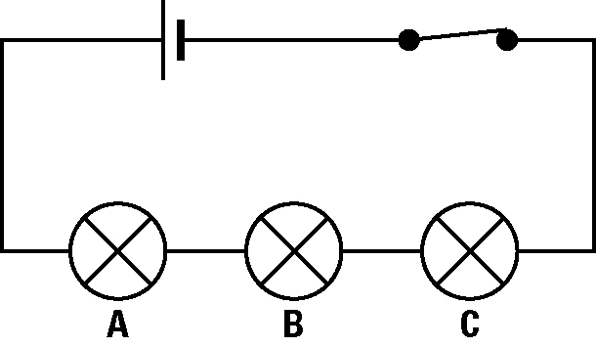 | (a) Compare the brightness of the three lamps.  (b) Compare the currents that flow through lamp A and lamp C.  (c) If the filament in bulb B burns out, will any of the lights remain lit? Explain.

Circuit two
2. Consider the following circuit containing identical lamps A, B and C parallel. These lamps are the same as those for Circuit 1.
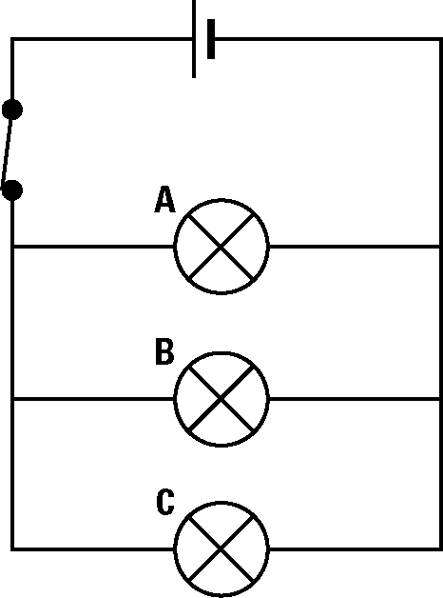 | (a) Compare the brightness of the three lamps.  (b) Compare the currents that flow through lamp A and lamp C.  (c) Compare the brightness of the lamps in Circuit 2 to their brightness in Circuit 1. Explain any differences.

Circuit three
3. Consider the following circuit consisting of 3 lamps and 3 switches.
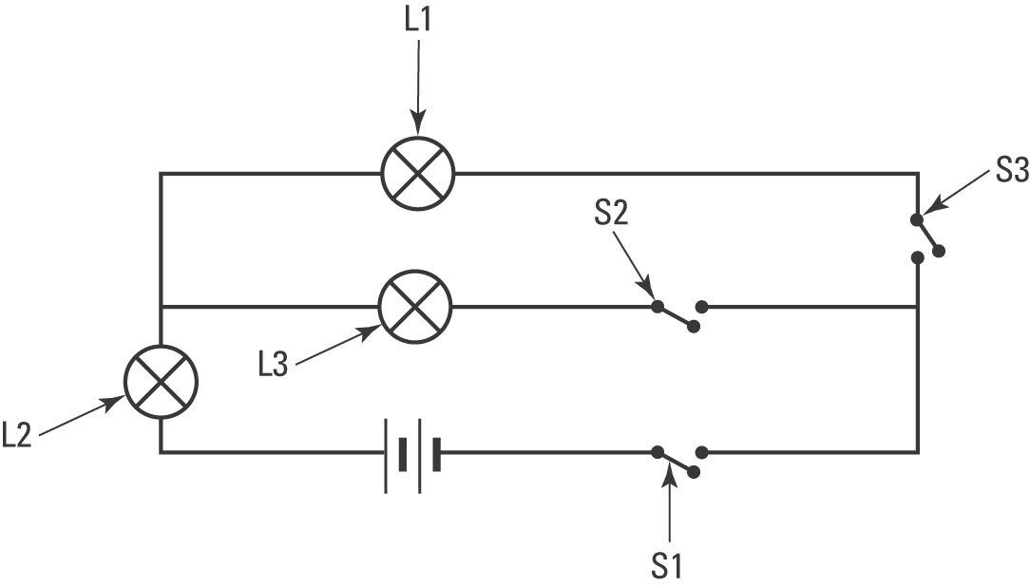 | Predict which lamp(s) will light when:  (a) switches S1 and S2 are closed  (b) switches S1 and S3 are closed  (c) switches S2 and S3 are closed.

